whareongaonga 5 blocks trust
  - august 2020
  - pānui #2

-SHAREHOLDER’S UPDATE-
AGM Highlights
Thank you to all those who supported and provided resources for our AGM this year; acknowledging Tāmanuhiri Tutu Poroporo Trust for the livestream and Muriwai Marae for the venue and catering.
A copy of the Chair’s report is attached to this pānui, with the additional updates tabled at the AGM.

Trustee’s update
- Henare Porou was reinstated as Trustee
- Jo Pleydell joins us as a new Trustee

Financial update
We have changed to an April>March financial year, which makes for a standard financial reporting position and our AGM’s can be held earlier in the year (i.e., August and on a Saturday).

Education Grants
We approved 17 recipients for the Tertiary Education
Grants who received $400 each.
Recipients are listed at the end of this newsletter;
it is great to see the length and breadth
of study options for our mokopuna.

Shareholders are invited to our website to download AGM report, Chair’s report and stay connected with our updates.

www.whareongaonga.com
whareongaonga5@gmail.com
06-8691400 (BDO office)

WAAHI TAPU MANAGEMENT    We are establishing a waahi tapu management policy, with thanks to Noel Pohatu who has marked sites of significance around the block. This is a work in progress, we would appreciate your input as we work towards ensuring urupā, protected sites and ensuring there are protected sites with the Aratu Forests lease. | AGM livestream attendance  5% from overseas  25% Tāmaki Makaurau  20% Wellington  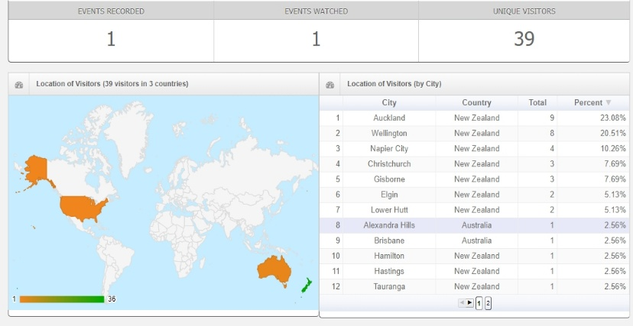  50% Nation-wide
New Trustee J. Pleydell & Reinstated Trustee H. Porou | Strategic Projects Manager    With the approval of our PGF grant, the Trustees discussed the importance of ensuring this project achieved successfully.  The grant is focused on fence ways across the W5 tributaries including pest control, employing local whānau and an education/employment opportunity for local whānau.  In addition, we wanted to ensure strong leadership over this fund.  To give transparency to the management of the grant, Matene Blandford resigned as Trustee and appointed as Strategic Projects Manager to oversee the grant and the following key portfolio’s:  - Waahi Tapu management policy  - Forestry lease with Aratu Forests (review and re-negotiation)  - 1BT grant management oversight (Strategic Plan Goal)  - PGF application for Natives regeneration (Strategic Plan Goal)  - General management of homestead, operations and H&S policy
Tāmanuhiri Hunting Club
The Board has agreed to a request for the Tāmanuhiri Kaitieki (Hunting Club) to have exclusive access to the W5 lands within the Aratu Forest Ltd lease arrangement. In addition, it also means that our whānau are walking the land and working with the block as to how the rest of the whenua can be looked after as well. Nō mātou te whiwhi!


www.whareongaonga.com | 06-8691400 (BDO Office Gisborne) | whareongaonga5@gmail.com

EDUCATION GRANT RECIPIENTS 2020

We are proud to present this years Education Grant Recipients for 2020.
We have contacted each of them to share their education journey with the Whareongaonga Whanau.
Below are the names of the 17 Recipients and their chosen field of study.



Whāia te mātauranga hei oranga mō koutou
This whakatauki refers to the importance of learning for it is key to your wellbeing.
If you follow the path of learning, the world will be your oyster

Education Grant - Profile
Kellann Kemp is one of our Education Grant
Recipients with whakapapa ties to Whareongaonga.
This is her story

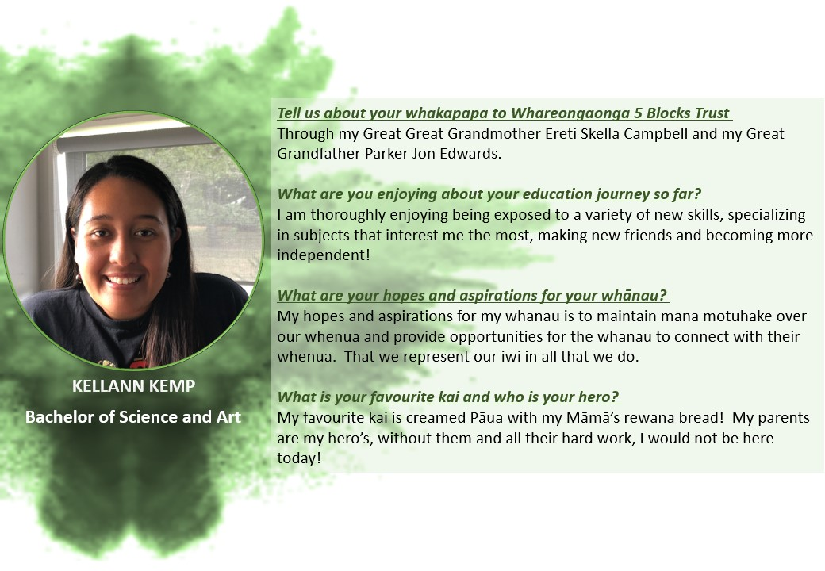
Ki te whakamana te mauri o Whareongaonga

